Student’s name | …………………………………………………….…… | Grade | 2
Subject | Computer | Quiz No. | 1
Quiz No. ( 1 ) (Answer)

10

write the correct name of each part.

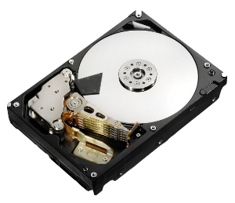


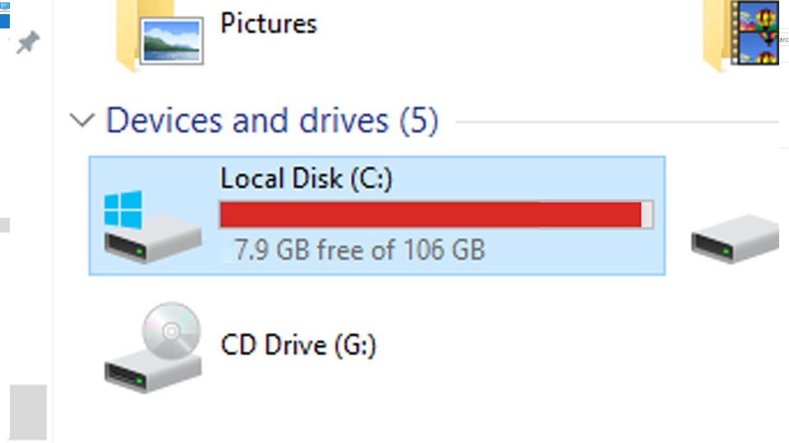
C: Drive
File
Folder
Hard Disk
Good Luck

C: Drive
Folder
Vector
File
Hard Disk

